Jack Johnson

September 7, 2021

Section End Project: Connecting MongoDB to Website

Link to my GitHub repository: <https://github.com/jjohn98/2058519_Jack_Johnson_Mean_Stack>

This project is located in ~/Phase3/Connecting MongoDB to Website.

For this project, I created 5 files. The 4 html files simply contain all of the html code for handling the user input and then passing this data to the express server. Server.js is the main file which handles all of the adding, updating, deleting, fetching, and routing of the webpages. All of these use the MongoDB database “coursePlatform” and the collection “courses”.

The add method just adds a new item the to collection in the database with the given course id, course name, course description, and course cost.

The update method finds the given course id within the collection and updates them all using updateMany() to the new course cost.

The delete method finds the given course id within the collection and deletes all of them with that id using deleteMany().

The fetch function lists all of the courses in a table by using the find method on the collection.

The files for this project will be in the GitHub repository, as well as the source code section of the submission on Simplilearn.

**Screenshots of Webpages and MongoDB verification:**

Dashboard:



Add Course page:

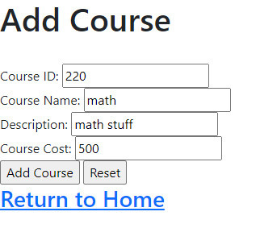

After successfully added to MongoDB:

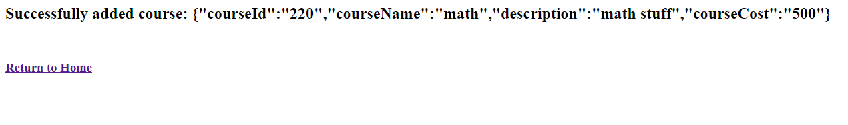

Update Page:

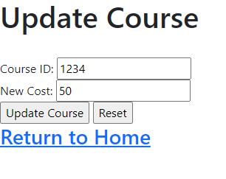

Successful update:

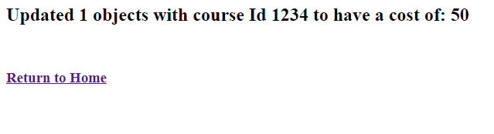

Delete page:

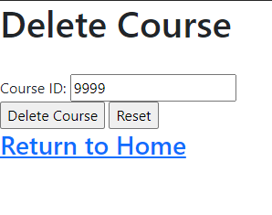

Successful Delete:

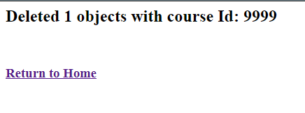

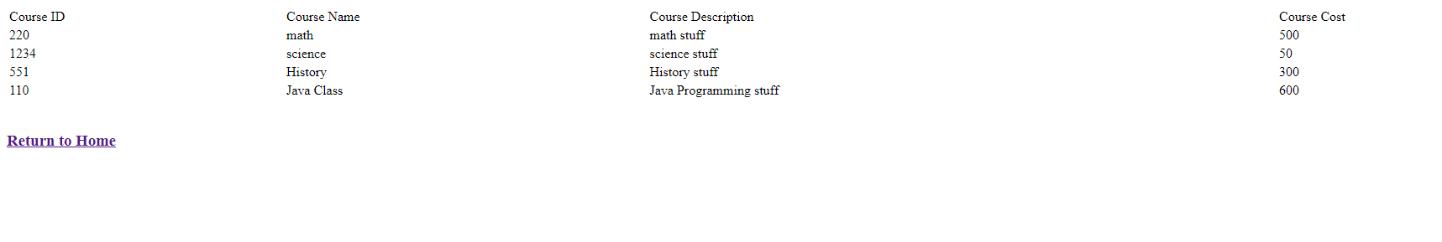Fetch Page:

MongoDB verification (should be the same as fetch page!):